Banner at the top be bigger and more prominent

Can the ticks used throughout be the same as the ones on original website
Rolling pictures are too blurred cant make out what they are
Take out “on time uk wide arrival”
Services – make the fully inclusive pat testing feature more, microwave leakage testing and emergency light testing are services we don’t want to overly promote
Why pat test doesn’t need to be on front page – also its not a legal requirement to pat test so change wording slightly also there is no prosecution risk

What our clients say…can we link to google reviews here too?
Disclousure and barring service – would change this to say Engineers are fully checked and take out insured to 5m as this is standard practice
Take out any reference to Uk wide.

SERVICES change text:
Cable repairs - The majority of items which fail a visual PAT testing inspection are due to damaged cable and flex. Heavily used items such as vacuums and 110v site equipment can all be damaged through general wear and tear. Replacement of cable/flex can be undertaken by Fused UK
IET code of practice picture is out of date. This is new one

Emergency light testing any image like this one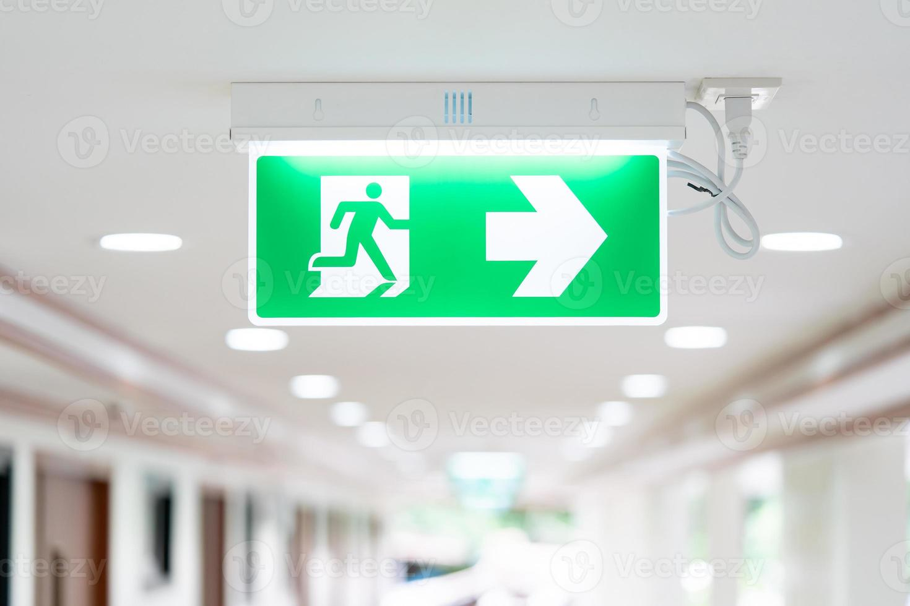
Renewal reminder service maybe image of a calendar?

Asset reports –
To accompany your annual PAT test certificate, our engineers will produce a detailed electrical testing report that lists all the assets tested. This report will also help towards documentating your asset lists in case of audit/inspection.
Customers are supplied with an itemised appliance register, Certificate of PAT testing and list of failed and passed items. Reports are provided free of charge in a bound folder (where appropriate) and can also be provided via pdf.
Why pat test – this can be made more shorter as just a short reason why to pat test.

The landlord legal requirements section type is different to rest of the body.

About us
Picture is cropping top of heads
What we offer

Change the cost effective solutions to:

Based in Leeds we provide professional UK wide, electrical testing solutions, with the added guarantee that wherever you are in the UK our engineers will be on time, every time.

Service features
Take out on time guarantee – replace with
Professional service with minimal disruption to the workplace

Who we work with
Our customer base is continually expanding and we provide electrical testing services to a range of customers including but not limited to GP surgeries, schools, nurseries, shops, restaurants, facility management companies and factories.
Some clients we work with Add the logos that Ash used for NHS, Arc inspirations etc
Add some pictures that I sent you from facebook of testing

